# Aloquin’s vision

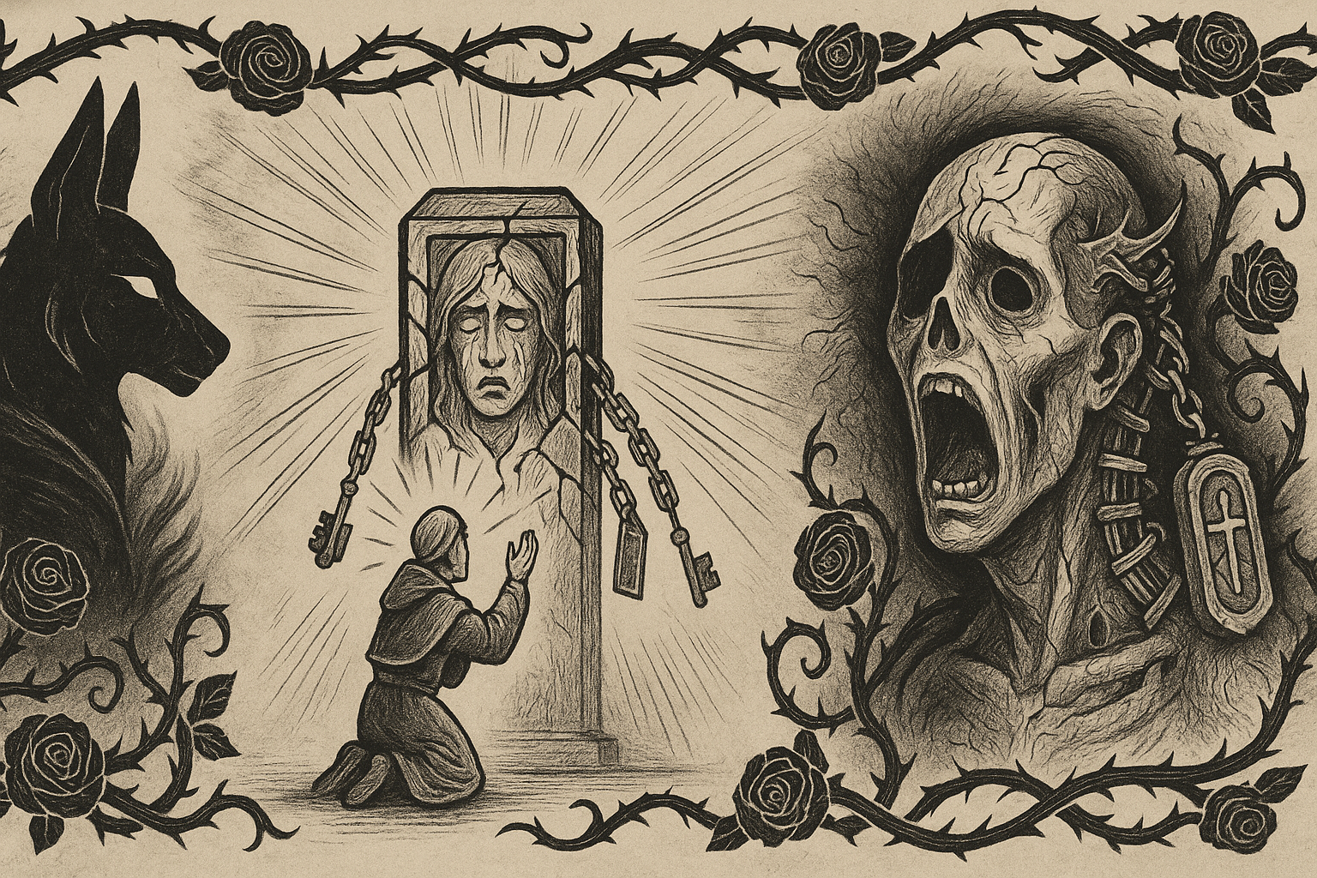

*The sky dims. All light turns monochrome. A faint toll echoes—three times. Time halts. Only Aloquin sees it.*

A veil of black roses blooms around Aloquin’s eyes. A jackal-headed silhouette—wreathed in mist—emerges beside him. It speaks in a voice of wind over dry tombstones:

**“The soul you seek to free is not bound by death, but by memory. What they called a sealing was a crime against the cycle.”**

*The vision shifts. The party sees a priest kneel before the Idol, hands raised. A ritual begins. The priest's body starts to fracture, eyes leaking light. The Idol's stone cracks open—and breathes.*

**“They tried to contain Elira’s pain inside stone. Instead, they fused her grief, her soul, and the lies of her faith into one vessel. A reliquary of torment. A mirror of betrayal. It is not sealed. It is feeding.”**

*The Idol’s face forms in the vision—half stone, half memory, screaming in silence. A ring of relics threads its spine.*

**“This is the Soul Drinker Idol. It remembers not as witness, but as wound. It drinks what cannot be buried. It punishes attempts to end the cycle, because it believes it is the cycle.”**

The Deathwarden looks directly at Aloquin.

**“Break it. Free her. Or join the ranks of those who worship their sins in silence.”**

*The vision ends.*

# What would Aloquin think of the Soul Drinker Idol?

Context: Aloquin serves the Deathwarden, whose dogma includes preserving balance and guarding souls from exploitation or defilement.

**🎭 Aloquin’s View of the Soul Drinker Idol**

Aloquin would see the **Soul Drinker Idol** as a **blasphemous abomination**—not because of its origin, but because of its **purpose and effect**:

* **It traps souls**—the very crime the Deathwarden abhors most.
* **It feeds on divine energy**, corrupting what was once sacred. To Aloquin, it is not just a cursed object but a **soul predator** masquerading as a relic.
* **It defies the cycle**—instead of release, it imprisons. Instead of rest, it consumes. That alone would fill him with cold fury.

He might speak to his companions in a voice that vibrates with restrained anger:

“This... thing was made to seal Elira’s pain. Instead, it feeds on it. Every soul it touches cries out for release, and the idol drinks deeper.

I feel them—trapped, spiraling.

We cannot allow it to remain. Whether shattered or sanctified, it must be severed from the cycle.”

**💡 RP Notes**

* Aloquin would **oppose looting** the idol for power unless it served a sanctifying or purifying end.
* He might **insist** on using the **Obsidian Shard** to bind or neutralize the idol, seeing it as his sacred duty.
* He could perform a **death rite**, channeling souls trapped in the idol to their rest—this could be a mechanic or flavor moment if you choose.